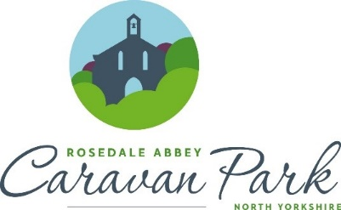
Rosedale Abbey Caravan Park Protocol for Reducing the Spread of Coronavirus
Holiday Cottages – Revised Oct 2021

Here at Rosedale Abbey Caravan Park, we are committed to protecting the health of our visitors and staff. We have put a number of measures in place which may make your stay a little different to usual.
Firstly, and most importantly we insist that you do not travel to Rosedale Abbey Caravan Park if you or any of your household have symptoms of COVID-19.
Preparations for your stay
- Prior to your arrival, your accommodation will have been vacant for at least 6 hours and will have been professionally cleaned and disinfected by our team. We are using the latest products available to us to ensure our Holiday Cottages are as safe as possible for our visitors.
- Windows will be left open to thoroughly ventilate the property
- Our cottages are supplied with disinfectant spray, handwash, disposable towels and bin liners
- You are welcome to bring your own bedding and towels if you wish – please inform us prior to arrival if you are doing so
Check – in
We aim to make check-in as contactless as possible.
- Balances are to be paid in advance please
- It is important you inform us of the correct registration for the car/s you will be arriving in. Our barrier operates on number-plate recognition so you can enter the park without the need to call it a Reception.
- Upon booking you will receive instructions on the whereabouts of your cottage and a code for the Key-Safe. Key safes and keys will be wiped clean with disinfectant prior to your arrival. Please let yourself into your accommodation.
- We kindly ask that you sanitise your hands before entering the property.
Reception/Shop
- We have placed hand sanitiser points, screens and signage to Reception to reduce the risk to our visitors and staff.
During your stay
- Holidaymakers can enjoy your accommodation, and the designated outdoor space. Public footpaths and cycle routes are open through and around the park.
- You can walk freely around the park, at all times.
- Please bring soap, hand gel and disinfectant with you – just to be on the safe side

Please do not
- Allow children to roam unsupervised around the park.
On departure
- Please check out by 10am, this is to ensure the property remains empty for the recommended amount of time before our team come in to clean.
- Please leave windows open to ventilate the property
- Please remove all bedding and towels and place in the bags provided. Please use separate bags for bedding and separate bags for towels
- Please dispose of any disposable cloths/sponges
- Please empty all bins and double bag and place in wheelie bins provided
- Please fill in the form to confirm that no member of your party has developed symptoms of COVID-19 during your stay.

