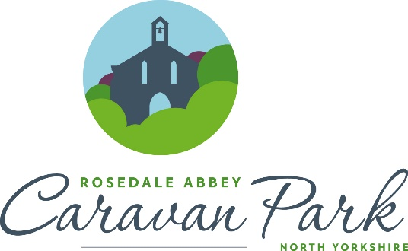

Seasonal Touring Caravan Pitches 2023

Friday 17th March – Sunday 29th October

Fully Serviced Hardstanding
Caravan & Awning Pitch - £1950.00

Prices are inclusive of Rates, Water Rates and VAT at the current rate.
Electricity is charged separately via Electric Cards which are purchased from Reception.

